**Lab 5:**

REACT is a javascript library. It can build the interface. Sometimes the data need to be revalidated by the reactive JavaScript frameworks such as Angular and React when a page renders. After this, many requests will be led between various external services and the front end and back end. Using the axios, we can keep things D.R.Y with default, interceptors, and instances. The complex applications use axios, which are frequently making API requests. Different APIs can be created the separate instances. In order to handle the global error, we can set interceptors. For common headers, the default can be unset or set. A little more functionality is provided by axios. The functionality will be useful for those applications that use React.

Axios is a kind of nmp package which is used to send the http request from our application. The api of "jsonplaceholder" uses the axios package to delete the data, and we will use this api in our example. When we use the web to access resources, this process is not instantaneous. The promise API is contained by JavaScript. When we want to perform asynchronous tasks, these promises will be useful. Asynchronous tasks are very useful to perform things in sequence. That means it does not change any things from happening.

**Part 1: Create a new REACT application that uses http requests to display data and delete data**

In this lab, you should build an application that displays a list of photos in a table. The first column should include the id of the photo, the second column should include the title of the photo, then the third column should include the Thumbnail of the photo as an image and the last column include “delete” buttons (one for each row).

For displaying the list of photos, use axios get method to get the data from <https://jsonplaceholder.typicode.com/photos> . the call should be included in the “componentDidMount” function

Then for the delete row functionality, you should have a new method handler for the button click, name it “deleteRow” and it will be called on button click. Inside the method “deleteRow”, use the axios method “delete” and send the id of the row that you want to delete.  
axios.delete(`https://jsonplaceholder.typicode.com/photos/${id}`){}

In the data in jsonplaceholder, you have the url of the images “thumbnailUrl”, use that to display the images in the third column as the following screenshot.

Use a separate css file to do the table css.

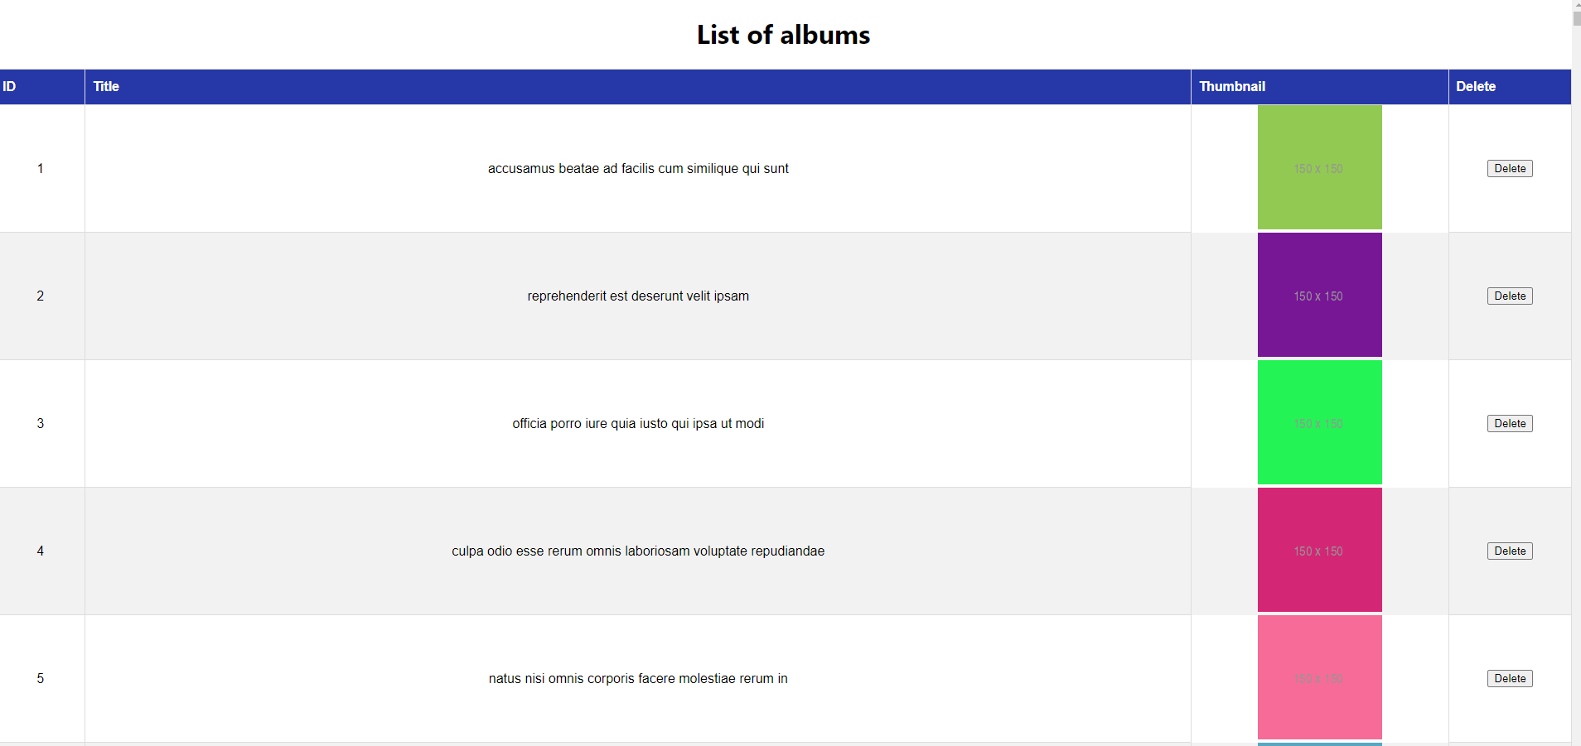

**Expected result:** You can customize it in the way that you like if you have better designs but keep it table



**Part 2: Create Simple Sign up form with React JS code**

Create another component that makes it possible to add a new photo to the list of photos. You should just ask the user to enter the id and the title of the photo.  
Test that by inspecting the application running.

**Expected result:** You can customize it in the way that you like

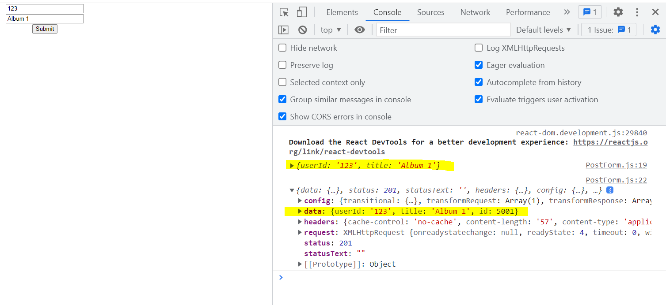

Submit your application on github and submit the github link on d2l. You should submit **ALL** the following:

* Github link
* 2 screen shots of the 2 pages runnning